Operation guides
Step 1: Find our homepage
In order to achieve the best browsing effect, it is recommended to use Google Chrome browser. You should enter the website address http://47.107.108.32/ and the website home page is as follow (picture 1).
Picture 1

Step 2: Log in.
This training course is only open to members whose user name and password has been send through email. Log in before attending the class.
As follows: picture 2, picture 3
picture 2
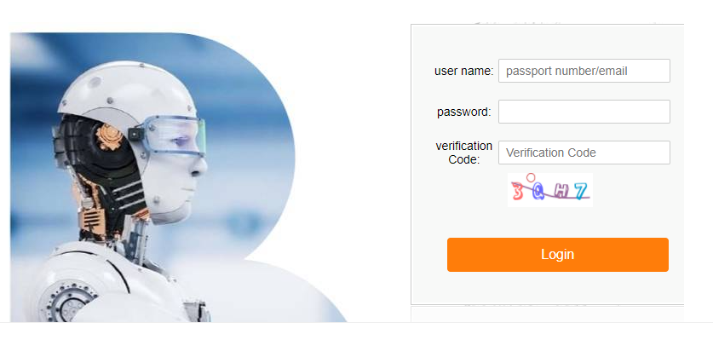 Picture 3

Step 3：Start learning
Click "watch the video" to start learning
As follows: picture4, picture 5
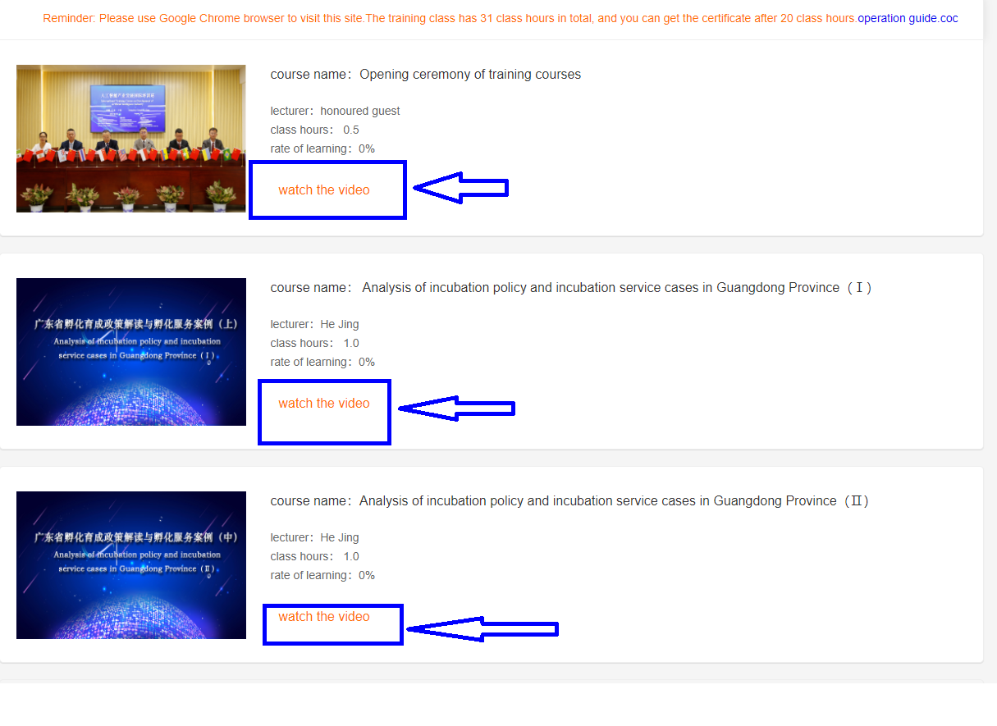
Picture 4,
Picture 5
The training class has 31 class hours in total, and you can get the certificate after you have obtained 20 class hours.

Step 4: Download “certificate” and “satisfaction questionnaire”.
When you finishes 20 class hours, the “Certificate Download” could generated and then you can download certificate.
As follows: Picture 6, Picture 7.
Picture 6
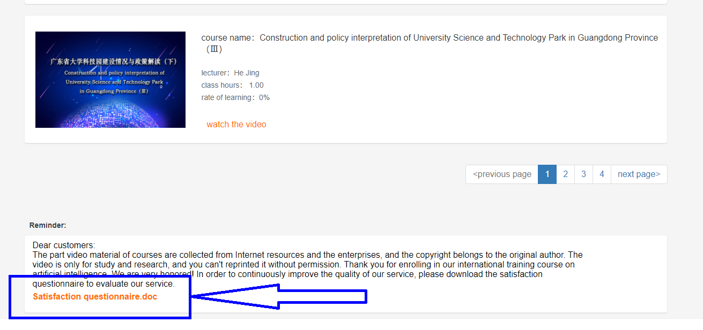
Picture 7

